

**2020 ASEE MODEL DESIGN COMPETITION**

**Sponsored by the Two Year College Division of ASEE**

**Event Name:** Hockey Skirmish

**Objective:**

To program an autonomous robot that can successfully visit four puck locations around the track and travel around the puck a randomly chosen number of times. The puck locations must be visited in a specific order that will be randomly selected. The robots will have a maximum time of 120 seconds in each of their four allotted trials.

**Track Specifications:**

**Figure 1: Isometric View of the Track**

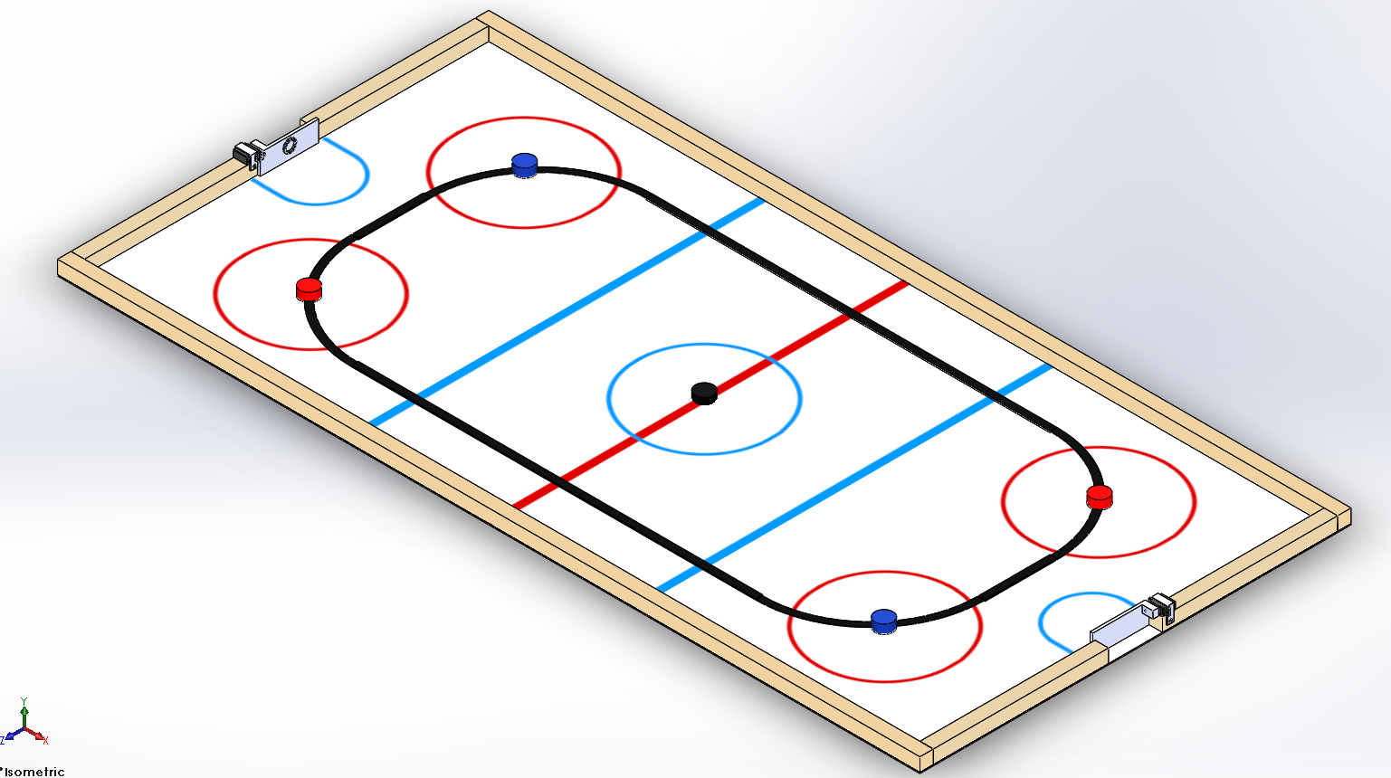

1. **The far goal is the red goalie and the near goal is the blue goalie, each is identified by a neopixel ring emitting the corresponding color for that goalie.**
2. **The pucks locations will be identified as follows, starting from the furthest puck in the figure and moving clockwise, 1, 2, 3, and 4.**
3. **The goalies will expose the goal for ~3 seconds and obstruct the goal for ~2 seconds in an endless loop.**

**Robot Time Trial Rules:**

1. It is the responsibility of the team to inspect the condition of the track before starting their robot to be certain that everything is in order. Once a team presses or pulls the start mechanism, the run counts as an official trial and may not be done over.
2. The order of testing will be determined by random draw.
3. Each team will have one minute to begin a trial after being called.
4. All teams will be called for a trial in a current round before any teams begin the next round of testing.
5. The robot must start within the vertical plane of the center face-off circle.

1. The first mission can be found in a table at the end of this document. For trials 2, 3, and 4, a random mission will be revealed at the end of each trial. That is, after trial 1, trial 2’s mission will be revealed. The mission will determine the order of which to visit each of the four puck locations as well as the number of times to travel around each puck location.
2. The time for a trial will begin when the judge gives the team the command to start. Once this start command is given, a team may only activate a single switch or mechanism to start the robot. Once the robot begins to move in any way, team members may not touch the robot or send commands to control it with any remote-control device.
3. If a robot fails to move once the judge’s start command is given, the team members may work on their robot to get it moving but the time will continue to run from the time when the start command was given. If the robot has not moved within 120 seconds of the start command, a score of zero will be assigned for that trial.
4. A trial will end when any of the following actions occur:

a. The robot becomes disabled or shows no evidence of being able to continue.

b. The robot has successfully completed the random mission and returned to the center face-off circle

c. The team chooses to end their run.

d. 120 seconds elapses from the start command.

1. Teams may make changes or repairs to their robots between trials but they must be ready within one minute of being called to the track.
2. Teams may not make practice runs after the start of the Robot Time Trials.
3. Note that no trials will be allowed on the last three missions since the time trials will have begun.

**Robot Time Trial Scoring:**

Robots will earn points by successfully completing the random mission.

A mission is considered successfully completed when the following criteria are met

* The robot started within the center face-off circle
* Each of the four puck locations were visited in the correct order
* The correct number of circles around each puck locations were performed
* The robot has returned to the center face-off circle and **some part of the robot** is within the vertical plane of the center face-off circle

A puck location is considered successfully visited when any one of the following occurs

* The robot begins to circle the puck location
* The robot sounds a buzzer

1. **Points earned for successfully traveling around a puck location:** **50 Points** will be awarded each time the correct number of circles has been performed around the correct puck location.
2. **Points earned for successfully visiting each puck location in the correct order:** **100 Points** will be awarded for visiting the puck locations in the correct order.
3. **Bonus points:** **100 points** will be awarded for a successful mission, see above for the definition of a successful mission.

Example: The random mission is determined to be

|  |  |  |  |  |
| --- | --- | --- | --- | --- |
|  | **Random Mission** | | **Actual Performance** | |
| **Order** | **Puck location** | **# Circles** | **Visited** | **# Circles** |
| First Location | 1 | 2 | **1** | **2** |
| Second Location | 3 | 4 | **3** | **4** |
| Third Location | 2 | 2 | **2** | **1** |
| Fourth Location | 4 | 3 | **4** | **3** |

The team would **not** receive the bonus as they only performed 1 circle around the third location. They would receive 50 points for each correct circle count for 150 points. They would receive 100 points for visiting all locations in the correct order. The team’s total score would be 250 points.

# Mission 1:

|  |  |  |
| --- | --- | --- |
| **Order** | **Puck location** | **# Circles** |
| First Location | 1 | 2 |
| Second Location | 3 | 4 |
| Third Location | 2 | 2 |
| Fourth Location | 4 | 3 |